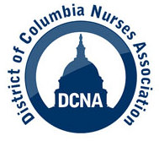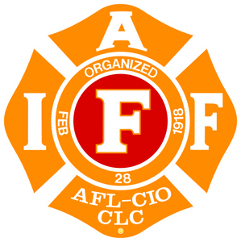
For Immediate Release
10/24/14
Contact: Edward J. Smith, Esq. Esmith@dcna.org Acting Executive Director (202) 425-8011

NURSES AND FIRST RESPONDERS CALL ON MAYOR GRAY AND DC CITY COUNCIL TO ENSURE HEALTH CARE WORKERS AND THE PUBLIC ARE PROTECTED AGAINST THE SPREAD OF THE EBOLA VIRUS

The District of Columbia Nurses Association and Fire Fighters Local 36 are calling on DC Mayor Vincent Gray and the DC City Council to immediately ensure that strict Ebola protocols and workplace safety standards are in place at all DC health care institutions.

DCNA Acting Executive Director Edward J. Smith and Fire Fighters Local 36 President Ed Smith will hold a press conference on the steps of the Wilson Building Friday, October 24 at 9am prior to testifying at a City Council Committee on Health hearing at 10am.

In light of the recent situation in Northern Virginia with first responders unable to take a possible Ebola patient to the closest hospital because that hospital was not prepared, it is critical that the DC government act now. DCNA and IAFF 36 are calling on the Mayor and City Council to direct health care institutions to take these minimum measures:

- Personal protective equipment that meets or exceeds the standards utilized by the University of Nebraska Medical Center. This includes the use of full body hazmat suits with OSHA approved powered air purifying respirators with a protection factor of 50 or above, or a higher standard, as appropriate.

- Negative pressure isolation rooms with an anteroom for changing personal protective equipment.

- Continuous, interactive training with workers who are exposed to patients, including updates responsive to the changing nature of the Ebola virus.

- Requiring that at least two direct care registered nurses care for each Ebola patient, with additional registered nurses assigned if the direct care RNs believe it is necessary, based upon their professional judgment.

- Utilize only waste disposal methods that follow national guidelines and that include worker training and appropriate personal protective equipment.

DCNA and IAFF 36 are committed to collaborating with the Department of Health, hospitals and other agencies to provide a safe working environment so that our members have the proper tools to fight this and other public health crises. DCNA represents over 2000 registered nurses and health care professionals in the District of Columbia, and IAFF 36 represents 1700 DC Fire Department workers.

